**PROGRAMS**

**Write a program to print Fibonacci series[0 1 1 2 3 5].**

import java.util.Scanner;

class FibonacciSeries {

public static void main(String[] args) {

Scanner scanner = new Scanner(System.in);

System.out.print("Enter the number of terms in the Fibonacci series: ");

int numTerms = scanner.nextInt();

int term1 = 0, term2 = 1;

System.out.print("Fibonacci Series: " + term1 + " " + term2);

for (int i = 2; i < numTerms; i++) {

int nextTerm = term1 + term2;

System.out.print(" " + nextTerm);

term1 = term2;

term2 = nextTerm;

}

System.out.println();

}

}

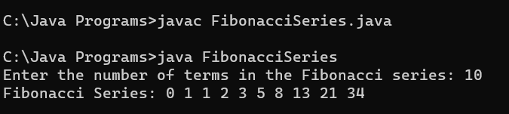

**Write a program to find the reverse of number.**

import java.util.Scanner;

class ReverseNumber {

public static void main(String[] args) {

Scanner scanner = new Scanner(System.in);

System.out.print("Enter a number: ");

int number = scanner.nextInt();

int reversedNumber = 0;

int originalNumber = number;

while (number != 0) {

int digit = number % 10;

reversedNumber = reversedNumber * 10 + digit;

number /= 10;

}

System.out.println("Original number: " + originalNumber);

System.out.println("Reversed number: " + reversedNumber);

}

}

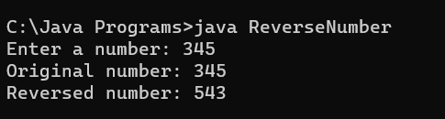

**Write a program to check whether the given number is Palindrome/Not.**

import java.util.Scanner;

class PalindromeChecker {

public static void main(String[] args) {

Scanner scanner = new Scanner(System.in);

System.out.print("Enter a number: ");

int number = scanner.nextInt();

if (isPalindrome(number)) {

System.out.println(number + " is a palindrome.");

} else {

System.out.println(number + " is not a palindrome.");

}

}

public static boolean isPalindrome(int num) {

int originalNum = num;

int reversedNum = 0;

while (num > 0) {

int digit = num % 10;

reversedNum = reversedNum * 10 + digit;

num /= 10;

}

return originalNum == reversedNum;

}

}

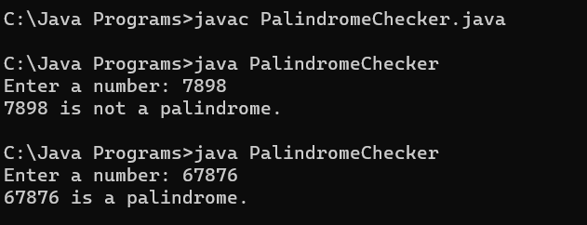

**Write a program to check whether the given number is Armstrong/Not.**

import java.util.Scanner;

class ArmstrongNumberChecker {

public static void main(String[] args) {

Scanner scanner = new Scanner(System.in);

System.out.print("Enter a number: ");

int number = scanner.nextInt();

if (isArmstrong(number)) {

System.out.println(number + " is an Armstrong number.");

} else {

System.out.println(number + " is not an Armstrong number.");

}

}

public static boolean isArmstrong(int num) {

int originalNum = num;

int numDigits = countDigits(num);

int sum = 0;

while (num > 0) {

int digit = num % 10;

sum += Math.pow(digit, numDigits);

num /= 10;

}

return originalNum == sum;

}

public static int countDigits(int num) {

int count = 0;

while (num != 0) {

num /= 10;

count++;

}

return count;

}

}

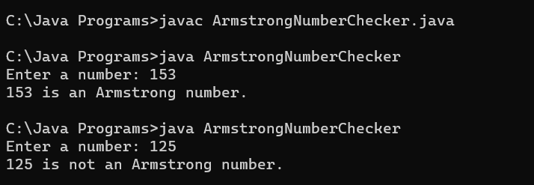

**Write a program to check whether the given number is Prime/Not.**

import java.util.Scanner;

class PrimeNumberChecker {

public static void main(String[] args) {

Scanner scanner = new Scanner(System.in);

System.out.print("Enter a number: ");

int number = scanner.nextInt();

scanner.close();

if (isPrime(number)) {

System.out.println(number + " is a prime number.");

} else {

System.out.println(number + " is not a prime number.");

}

}

public static boolean isPrime(int num) {

if (num <= 1) {

return false;

}

for (int i = 2; i <= Math.sqrt(num); i++) {

if (num % i == 0) {

return false;

}

}

return true;

}

}

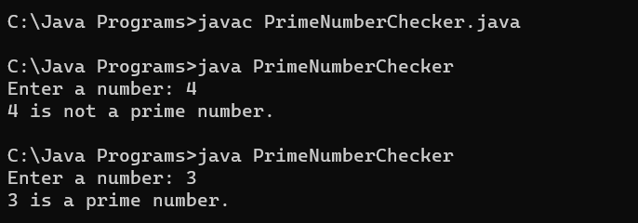

**Write a program to find the count of even numbers and odd numbers from 10 to 20.**

class EvenOddCounter {

public static void main(String[] args) {

int start = 10;

int end = 20;

int evenCount = 0;

int oddCount = 0;

for (int i = start; i <= end; i++) {

if (i % 2 == 0) {

evenCount++;

} else {

oddCount++;

}

}

System.out.println("Count of even numbers: " + evenCount);

System.out.println("Count of odd numbers: " + oddCount);

}

}

